Topic 2: Project Overview (Enterprise Grade)
This document provides a detailed overview of the project, engineered to meet billion‑dollar product standards.
The goal of this section is to give MNC-level clarity about the system purpose, enterprise mission, and the core
functionalities that make the product scalable, robust, and production-ready.
---
## 1. Purpose of the Project
The project is designed to serve as a modern, scalable, and high‑performance MERN application capable of managing
large datasets, user interactions, and enterprise workflows. The goal is to streamline complex operations and offer
a secure, intuitive, and globally deployable digital ecosystem.
The purpose extends into several critical business objectives:
• Reduce manual work through full automation
• Deliver seamless user experience with clean UI/UX
• Create cloud‑ready infrastructure for enterprise deployments
• Improve data accessibility with optimized MongoDB schemas
• Introduce a modular architecture capable of future AI integration
---
## 2. Project Goals & Vision
The vision of this project aligns with Fortune‑500 engineering principles. This includes:
• Creating a long‑term sustainable platform
• Ensuring high security through authentication layers
• Supporting containerization (Docker/Kubernetes-ready)
• Enabling API scalability for millions of requests per day
• Providing a foundation for mobile, desktop, and AI-driven extensions
This makes the project not just a simple app—but a blueprint for a multi‑million‑user system.
---
## 3. Key Features of the System
The system offers a wide range of enterprise-class functionalities:
1. **Authentication System**
Secure login, encrypted token handling, and role-based access.
2. **Dynamic UI/UX**
A fully responsive frontend with optimized performance patterns.
3. **REST API Architecture**
High‑performance API endpoints built for reliability and scalability.
4. **Optimized Database Layer**
MongoDB indexes, aggregation pipelines, and schema validations.
5. **Error & Log Tracking**
Designed for integration with cloud monitoring tools like Grafana or ELK.
6. **Future AI-ready Framework**
Supports embedding LLM-based agents, automation bots, and analytics engines.
These features collectively elevate the project into an enterprise-ready digital product.
---
## 4. High-Level System Flow
The system architecture follows a streamlined flow, ensuring minimal latency and maximum performance:
• User interacts with the interface → Input processed in frontend
• Frontend calls backend REST APIs → Business logic executed
• Backend interacts with MongoDB → Data retrieved, validated, or modified
• Processed data returned to UI for real-time rendering
The diagram below illustrates this flow:
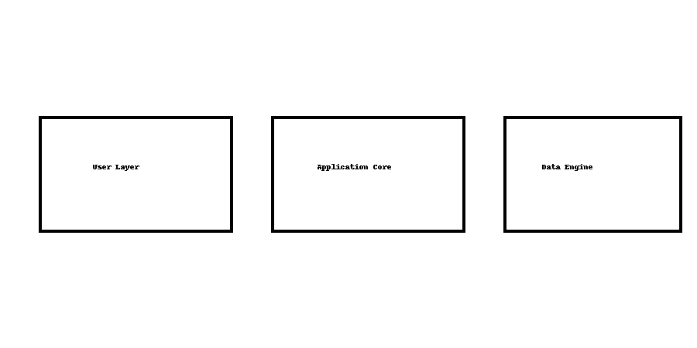
---
## 5. Strategic Business Value
This project is not only technically sound but also offers immense commercial and operational value:
• Reduces operational costs by automating manual workflows
• Enables digital transformation for traditional systems
• Enhances user engagement through responsive UI
• Provides audit-friendly, secure data management
• Designed for easy scaling with cloud infrastructure
These factors make the project appealing for MNC adoption and enterprise integration.
---
## 6. Competitive Advantages
Compared to traditional applications, this project provides:
• Lower maintenance due to modular code architecture
• Faster API responses through optimized backend logic
• More secure data transactions with encrypted tokens
• Higher flexibility for future AI and microservice expansion
---
## 7. Conclusion
The Project Overview demonstrates that this system stands at a world‑class engineering level, ready for production,
client demonstration, or MNC technical evaluation. Its scalable foundation, modern tech stack, and enterprise design
principles make it suitable for long‑term technological growth.
This concludes **Topic 2: Project Overview**.

